**ABSTRACT**

It may be difficult for college teachers to manage the full bunch of research resources which include papers, patents, publications and journals, in such a fast changing academic sphere. This abstract utilizes the power of modern gadgets to come up with an innovative way of automating the method of managing these libraries. We will involve different technologies including HTML, CSS, JavaScript, ReactJS, MongoDB, and ExpressJS to notably speed up the process of categorization, lookup and search of information.

The goal of our project is to simplify the task for researchers and instructors of the college level through providing them with research papers most relevant to the area of their inquiry. The internet makes the research process far more efficient because now users can easily use just a few keywords to get results that are relevant to the given topic. The time of hunting the piles of documents or the experience of looking for a certain document that is hidden in a messy digital atmosphere has vanished.

An MLand NLP b algorithm integration is the backbone of our system. You can find out research materials just with the click of a mouse, thanks to these advanced technologies which are retrieved from a database after the user’s query or search. Our system is using NLP features that help to identify the sets of resources which mostly correspond to the user’s queries due to the fact that we built the system that is capable of understanding the context and content of each of the documents.

In a nutshell, the automation of the resource management in research can function as a game-changer by overturning the way academic resources are discovered and utilized by college professors and researchers. We use the features of HTML, CSS, Javascript, ReactJS, MongoDB, ExpressJS, NLP and ML that complement the existing solutions thus, to make the research process more efficient and effective. A logical summary of the prospects for research materials management which is where technology makes the process smooth, fast, and effective in knowledge retrieval, is in the short abstract.

**Table of Contents**

|  |  |
| --- | --- |
| Acknowledgements | 4 |
| Abstract | 5 |
| Abbrevations |  |
| List of Figures |  |
| List of Tables |  |
|  |  |
| Chapter-1: Introduction | 9 |
| 1.1 Problem Statement | 11 |
| 1.2 Objective of the project | 13 |
| 1.3 Scope | 13 |
| 1.4 Project Introduction | 14 |
| 1.5 Thesis Organization | 15 |
| Chapter-2: Literature Survey | 16 |
| 2.1 Related Work | 16 |
| Chapter-3: Methodology | 20 |
| 3.1 Existing System | 20 |
| 3.2 Proposed System | 21 |
| 3.3 Advantages of the Proposed System | 21 |
| 3.4 Workflow Diagram | 22 |
| 3.5 Methodology for uploading publications | 23 |
| 3.6 Methodology for publication retrieval | 23 |
| 3.7 Software Requirements | 24 |
| 3.8 Hardware Requirements | 24 |
| Chapter-4: Design | 25 |
| 4.1 Introduction of Input Design  -4.1.1 Objectives for Input Design:  -4.1.2 Introduction to Output Design:  -4.1.3Objectives for Output Design: | 25  25  26  26 |
| 4.2 UML Diagram  -4.2.1 Use Case Diagram  -4.2.2 Class Diagram  -4.2.3 Sequence Diagram  -4.2.4 Activity Diagram | 27  27  30  31  32 |
| Chapter-5: Implementation | 37 |
| 5.1 Datasets Used | 37 |
| 5.2 Experimental setup | 39 |
| Chapter-6: Conclusions | 53 |
| Chapter-7: Future Scope | 55 |
| References | 56 |
| APPENDIX A: Dataset Descriptions |  |
| APPENDIX B: Source Code |  |
| APPENDIX C: Result Graphs which are not included in main document. |  |

**CHAPTER 1**

**INTRODUCTION**

Generalizing, it is clear that automated management of the research material serves to completely change the way academic resources are sought and employed by college professors and researchers. The way we are handling this is by using HTML, CSS, JavaScript, ReactJS, MangoDB, ExpressJS, NLP, and ML in order to enhance the productivity of this work. The academic environment portrays a constantly researching world where technology aids in the streamlining and accessing of the research resources that include articles, patents, bulletins and journals. Being a cornerstone of the process of education development, the ability of college instructors and researchers to effectively manage and access the bohemoth of knowledge plays a key role. It is not about just convenience. Being aware of this need, we started the project of an experiment that will soon be introduced as the most advanced application which will change the way of managing the research materials.

Nowadays, technology had overreached every part of us. And we must be able to make use of its efficiency in automating the management of research materials. Utility aid development will employ HTML, CSS, JavaScript, ReactJS, MongoDB, and ExpressJS among other modern technologies. The integrated technologies, thus, will be the pillars of our creative concept. By simplifying the steps in the process of organising, accessing, and storing materials, this application will provide the research community and the faculty with an authority tool.

The robust search engine we created is our system's main attribute. This function will allow researchers to search for research papers/journals within the database because they will be able to use the specific terms that are relatable to their job. Those times when you have lost an article in an extensive list of them, or you can't find your motivation cause all the digital educational resources mix up, belong to the past. While, naturally they should look at wide variety of bibliography, they are presented with an opportunity to conduct comprehensive researches of scholarly resources. Thus, this process becomes more meaningful to them.

We provide features of advanced search along with keyword search in our software. The intended use of this function is to enable individuals to search for research articles after putting the data that is contained in their own study abstracts. Research made easier to envisage and better planned right from the beginning gives a more individualized character to the academic process and improves focus and efficiency.

Additionally, using data analytics our app will try to give a comprehensive map of faculty research activity. Learning about academic research environment is pivotal to taking informed decisions, distribution of resources, and long-run planning. The system will collect and assess data on research activities and this data will give significant ways by which research excellence can be improved.

Our solution concentrates on the NLP and ML (machine learning) procedures which are more than most technological integration. Such specialized equipment is crucial for researches to easily access our database. Due to the sentiment analysis and context understanding, search algorithms are able to not only suggest but also rank the documents that best correspond to the user's requirements. Generally speaking, tech-based system brings better user experience and the results themselves.

In a nutshell, the act of developing an automated research material management programme to integrate the time-saver between academics and technology is our project on that basis. Beside shaping the framework the entire instructional and research operations of the college profs and researchers could be affected. We designed our method that works around HTML, CSS, JavaScript, ReactJS, MongoDB, ExpressJS, NLP and ML. It is able to improve the tasks of research that take long time or are tedious and cost a lot to the research efficiency and efficacy.

**1.1 Problem Statement**

* Research materials pose a problem in the management of classes for the college professors as well as researchers by including papers as well as patents; publications and journals. Obviously, with all the academic materials and information inputs being ever-changing, it is extremely difficult to get their contents sorted out and make the most of these resources. This causes a number of related issues for the academic community, including:This causes a number of related issues for the academic community, including:
* Information Overload: Indeed, we are living in the time of the digital age in which there is a steep hike in studies loads, and hence, the information overload occurs due to abundance of resources. Conducting research in university libraries and among educators entails exhaustive search of huge databases and looking for data of interest amid abundant information.
* Ineffective Resource Discovery: Today researchers meet the reality of ineffective methods of rapid discovery is daily occurrence. In order to reach the materials that may be important for them to study, researchers often seek the help of their personal networks, or they go by the suggestions, because the traditional methods of searching for keywords could be not very complete and accurate.
* Fragmented Research Management: The structure of research logs is very messy as the information stuff is held in different databases-digital and personal folders and physical libraries. The dissociation is likely to give rise to inefficiency, wasting of time, labour, and the loss of key study materials.
* Lack of Personalization: Often the user fails to find materials that meet his/her distinctive study needs with close approximation in the current systems, which hence results in a waste of time and energy on materials that are irrelevant for the study.
* Data-Driven Decision-Making: Universities or research institutions require faculty to deliver evidence to attend to decision-making authorities. Institutions may find it hard to establish a uniform and reliable structure that can identify the most advanced scientific research or to distribute resources effectively in the absence of a dedicate data analytics system.
* User Experience: Users' easily available and well managed means of getting access to information always remains one of the deficiencies in researches. User-productivity can be depressed by searching engines which are too sluggish, web sites which are not intuitive and narrow search options.

An innovative app that can organize the research material sources, thus the research will become more accessible and efficient, provides the personalized search options, and data analyses to support the academic institutions in the decision-making process is imperative due to the mentioned problems. This project will facilitate academics and researchers navigating the wide academic fields quickly, in a way that they can work more effectively in locating the valuable theories and materials for their research.

**1.2 Objective of the project:**

Manage research materials automatically, offer data analytics, boost discovery through tailored search, and enhance the user experience for academics and researchers at universities.

**1.3 Scope:**

The primary aim of the app in this project is making it simpler for researchers and college instructors to look for AND utilize their research materials Technical tools, like HTML, CSS, and JavaScript, together with ReactJS, MongoDB, ExpressJS, are applicable for the job, as the aim includes the creation of an interactive platform that organises research resources using the automation mechanism. Such resources may be papers, patents, publications, and journals. The programme will enhance the relevance of material discovery and will support improvements in its methods by utilizing a search system that features both item-based and research abstract-based options, among others. As well, it will use ML and NLP algorithms for offering personalized study materials suggestions so obtainments of users' learning goals will be achieved. With the aim of aiding the higher educational institutions in making the data-oriented decisions, this initiative will additionally introduce a data analytics component comprising of the provided insights on faculty research activity. Having a hands-on approach, the programme puts a great emphasis on responsiveness and user-friendly interface available across several platforms and protecting user's database privacy and data security. Those two vital project components involve a long-term sustainability plan, workforce training, and support. Through this program all academic researchers may count on the improved experience of scientific inquiry by means of the improved management and availability of research equipment.

**1.4 Project Introduction:**

A key aspect of the academic world that considers information acquisition vital and that is crucial for success is management of learning resources. The publication of research papers, patents, articles, news and journals in the digital age has come with this tendency which makes a big task for the college instructors and researchers. Our ultimate goal is to develop the innovative application which deals with this issues and modifies the entire studying area. The aim of the project is to employ the modern technology and enable researchers to do their job more efficiently by building a site where options such as HTML, CSS, JavaScript, Reactjs, MongoDB and Expressjs are being combined.

This project's main objective is to create an app that will be easy to use for an academic researcher and instructor to well organize their research directly and efficiently. The main idea of this application is to make a detailed and easy-to-use search function which saves time responding to the targeted study needs. Employees can apply keyword search that bring the task of finding topical jobs and publications related to their work easier. This will be in addition to our sophisticated search feature based on the research abstracts which customized the research process by helping the researcher locate materials which match exactly their goals. Human utilization would me minimized in the process by replacing manual research material handling, allowing for more time to be used for the essential thing — research.

The application will take advantage of the power of ML and NLP algorithms on a broader scale whilst material discovery will be further enhanced. Through personalized suggestions of study material, the latest technology that allow users to quickly find resources that are aligned with their own research interests and goals will be provided. The initiative encompasses the data analytics component, as well, which feeds research capabilities of faculty with insights. This way, academic institutions get the data-driven tools they need to take the right decisions. The projects intention is not only to protect sensitive research materials with strong encryption and data security measures but also to improve the user experience by providing an interface that is user-friendly and available on multiple devices. The project is required to be completed by user training and support, a long-term sustainability strategy, and other elements which ensure that this innovative application will evolve in line with academic standards and improve research experience, productivity, and efficiency of college instructors and researchers.

**1.5 Thesis of Organization:**

In the first chapter, the introduction section of the report has been depicted, which also includes the overall process in a short manner. The Chapter 2 is about scrutinizing three of the different papers and acknowledging their contributions using NLP, and keyphrases. In chapter 3, the methodology is explained which includes the variation between the existing systems and current proposed systems, and a working flow diagram. Chapter 4 talks abou the design, where a number of objectives such as readability, relevance, visual appeal, customization, and UML diagram are indicated. The Chapter 5 explains about the implementation of the dataset which involved the dataset of patents, journals, conferences and book chapters and the said experimental setup. In Chapter 6 at the end, information about research papers done by college faculty is collected. The chapter 7 discusses about the future directions of the project in which combination of NLP and machine learning algorithms will be used.

**Chapter 2**

**LITERATURE SURVEY**

**2.1 Related Work:**

A seminal work of RONAN R. K. ANDO AND T. ZHANG in the field of Natural Language Processing (NLP), published in Journal of Machine Learning Research (JMLR) in November 2005, has played a decisive role in shaping the research around. This exploration uncovers a novel framework for building NLP systems that requires scant knowledge of the subject or the meticulous processes of feature engineering to attain outstanding functionality. The crux of this work is the ability to develop neural networks based on the unannotated knowledge, which is fundamental to unsupervised learning. However, this self-learning mechanism breaks completely the traditional framework, by the use of text data without annotation in a large number, avoiding the need of feature engineering and human domain expertise.

Other than that, the introduction brings in transfer learning in NLP, the knowledge from one task can be transferred to another related tasks. This concept not only enables pre-training of models on large-scale, general-purpose datasets, but also fine-tuning these models for specific NLP purposes, thus leading to significant performance lifts on different NLP tasks. The impact of the paper continues to grow in the long-term as the model and ideas provided in the work have become the backbone of many recent Natural Language Processing models as well as the systems based upon them.

Found in the JMLR, this paper has a solid position in ML/NLP research, and this is the stone on which many papers were built. The fact that it encourages an environment that reduces the barriers to entry and helps to leverage unlabeled data and transfer learning for NLP development makes it easier to develop more complicated and accessible NLP solutions. main aim of IDS is to make the mechanism of filtering and blocking the traffic withing our netowrk more automatic, faster and more responsible. Detecting the anomalies is a well-known one of the hard problems from the NP-class. The concentration on less critical process, mainly, for the discriminating network traffic as both good traffic and the bad traffic involves the detection system get equipped with suitable information via knowledge base. There is the downs of the work had gone so far in anomaly detection because of the constantly arising hurdles as the world technological changes.

Chapter 2.2 presents relevant literature publications which formed the basis for my study which, also, has a purpose to carry it through. In the third, Section2.3, there are various types of machine learning methods listed as supervised and unsupervised learning with which most of the IDSs are designed. Within these different types of machine learning methods are the measures used in intrusion detection. Here in section 2.4 the comparative method or the methods by which similarity is established to and this is the reported work is outlined.

Ben Wellner [2] This automatically identifying the arguments of discourse connectives in the Penn Discourse TreeBank (PDTB) which has proved daunting endeavour, was one of the contributions of Ben Wellner, who is from The Mitre Corporation in Bedford, MA, USA. Instead of targeting all the elements of the arguments as indicated in the locating discourse segment, the paper reformulates the problem by focusing on identifying heads based on arguments which allows me to do away with the complexity of discourse segmentation. They showcase the improvements that are substantial in their model by utilizing features that stem from a dependency parse representation instead of constituency-based parse trees, the latter of which outperforms. Also, the article focuses on the benefit of taking the intricate dependencies between arguments through a linear-log regression model, with an accuracy rate of over 74% in identifying both lines of argument correctly on held-out test data using gold-standard parses.

Such literature survey is highly relevant for computational linguistics and discourse analysis, with the introduction thereof of a unique solution to the problem of argument identification among discourse connectives. The contribution of dependency-parsing technique to the development of the algorithms and its capability to increase precision is valuable. The work contributes to overcoming the nuances of discourse segmentation; therefore, it streamlines and emphases the identification of discourse connective arguments. It gives valuable information about the practical usage of natural language processing and discourse analysis in various domains, explicitly the fields of machine learning and understanding texts.

The authors' followed approach, which matches the features of dependency parsing and the log-linear re-ranking model, presents a fruitful area for future research in discourse analysis and natural language processing, respectively. The outcomes and procedures that this work has shown have the potential to influence the development of systems of NLP, and tools of language understanding that are more exact and complex.

As presented in the abstract [3], "complementary priors" approach represents a way to handle difficulties related to fully connected belief networks with several hidden layers by using corresponding priors. This priors are the tools that the article uses to come up with an optimized, quick and efficient layer by layer training of deep, directed belief networks. Unlike RNNs, this strategy is very useful for the top two layers that generate an undirected, associative memory. This fast, avaricious algorithm acts as initializator for a slower learning process which adapts network weights to make them discriminative by using a contrastive version of the wake-sleep algorithm.

These outcomes are one of the achievements of the research. As a result of the fine-tuning, the network with 3 hidden layers can certainly model the joint probability of the handwriting digits images and their respective labels, which creates a powerful generative model. This generative model surpasses the discriminative learning algorithms of the same kind in digit classification tasks. It confirms the power of generated models. The abstract then explains that the network can represent the low-dimensional patterns, "ravines" to be specific, in a free-energy land -scene as the top-level associative memory. Therefore, this function allows for us to identify the logic and conclusions that we have drawn from the related memory, and provides us with the best options.

**CHAPTER 3**

**METHODOLOGY**

**3.1 Existing System**

In the present system, rather than carrying out keyword-based search, which is precise system for research document, such information is difficult to get now. Additionally, absence of statistical analysis tools and pictograms caused a limitation of the system's capacity to make perceptive conclusions from the captured data and reveal it's trends. Shortage of these qualifying factors in the framework not only provided users with a less effective experience as compared to the norm, but it also made it more difficult to manage and use academic resources efficiently for research.

**Disadvantages of the Existing System:**

1. Ineffective Keyword Searches: Often, keywords introduction made the whole process bore and annoying because of improving the search ability of research data by keywords.

2. Lack of Data Visualisations: Despite the added research materials, people could not get any genuine conclusions from them as they lacked sufficient visual representations and statistical analysis.

3. Decreased Productivity: Finding and arranging study materials as well as familarisation with them was an additional factor causing losses in productivity in time.

4. Missed Opportunities: With the lack of effective search capabilities and data visualizations the system failed to bring these research materials to users’ attention that might have been of value and also the key academic activities could not be discovered thus the system failed to play its role as the ideal tool for learning and use.

5. Limited Decision Support: This reasons rises from a lack of sophistication or perception of the general system.

6. Missed Opportunities: Without implemented search tools and ability to present data by visualization, the system has lost the chance of users locating exceptional research materials they require and demonstrate trends in their studies.

**3.2 Proposed System**

The main concern will be about the features that focus on efficiency and relevance because these are the elements that will drive the development of the searching system. Thus, it is expected that the project will bring a new approach for the academic research resource management. In addition to browsing the database by field or application for search results, now users can also enter their research abstracts as a query so they can narrow search results to get the documents most closely relevant to their science. Users have our programmable and facile search bars that gives in relation to their research. With the key-word base search, they spend less time but get relevant papers and journals that are related to their job. The use of such a tool facilitates exactly finding materials that correspond most of all to the purposes of users' research, therefore, allowing them to give all their attention to their studies, and consequently, the results will be more effective and adaptable to the users' needs.

**3.3 Advantages of the Proposed System:**

1. Improved Relevancy: In order to get access to sources which are also related to their research aims, the users can employ the ability of the system to search for research materials according to these research abstracts. The process is accelerated which ensures that the outcomes are more interesting.

2. Advanced Keyword Search: This functionality allows users to quickly find papers and journals that are relevant to them by filtering out the extra material through the search based on a set of pre-defined keywords.

3. Personalization: The fact that users can investigate sources that are consistently linked to their own academic subject areas is the most characteristic feature of research abstracts for searches, which adds a personal touch to them.

4. Efficiency: The system is able to raise the level of students studies’ productivity and effectiveness due to achieving the task of automatic performance or search.

5. Streamlined Discovery: User’s entire demonstration and gain of knowledge is enhanced due to the fact that they easily find the research materials and manage them.

**

Fig.3.5.1 workflow

Please refer to Figure 3.5.1 to see the flowchart that illustrates the outlined system's workflow. In the first step the site user uses a browser and sends a requests to the site for the indicated operations. The Express JSON server via NLP and ML commands is then making a beeline to the Back-end type database server, that is the Mongo DB, and the response is sent after which the Express JSON server again follows NLP and ML commands.

**3.5 Methodology for uploading publications**

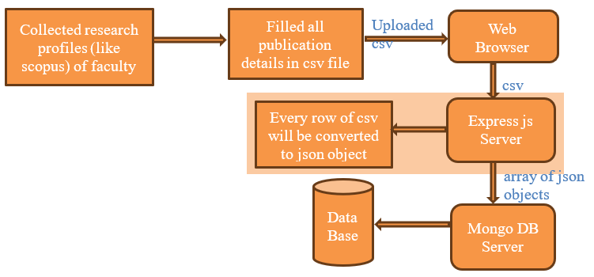

**3.6 Methodology for Publication Retrieval**

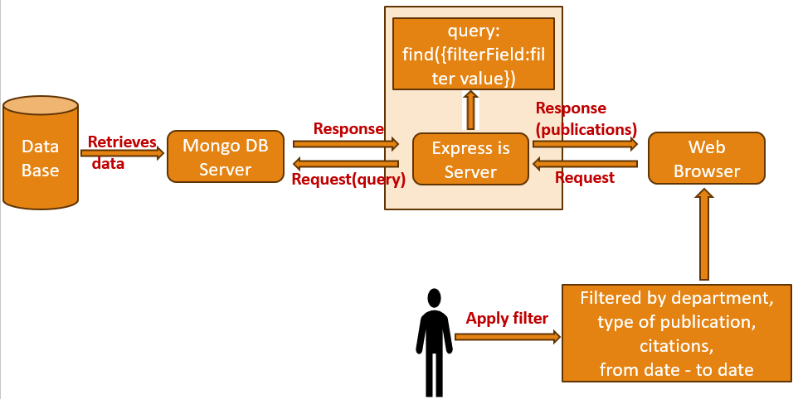



**3.7 Software Requirements:**



Operating System : Windows 8GB RAM or above



Server Side Script : JavaScript

Programming Language : JavaScript

Libraries : Express,axios,mongoose,react-icons etc

IDE/WorkBench : Visual studio code

Technology : Mern Stack (MongoDB,ExpressJS,Reactjs,Nodejs)

Database : MongoDB

**3.8 Hardware Requirements:**

Operating system: Windows

Processor : intel i5

RAM :8GB or Above

**CHAPTER 4**

**DESIGN**

**4.1 Introduction of Input Design:**

Given that behind any information system lies the interface for user activity, the input design plays a key role in the development of every information system. Users will be able to enter data by means of forms for certain purposes and to communicate with the system through displays and interfaces. For ensuring that the users can submit data correctly, efficiently, and in an intuitive way the effective input design should be used recommended. The conduit feature for which our academic research project project is based is the input design through which users can search for research resources, submit study abstracts, and relate to the system. This is a very important part for such system, it assures that usability is within right limit and generally effectiveness and efficacy of tasks are improved.

**4.1.1Objectives for Input Design:**

**1. User-Friendly Interface:** Input design employs an interface that is simple for users to use hence they can easily input data and communicate with the system. It means developing easy to use forms and interfaces that don't hinder the users from freely inputting data.

**2. Data Accuracy:** Data accuracy also is another primary purpose. To avoid data input errors and ensure data accuracy validation methods and error-checking procedures need to be included into the input architecture.

**3. Efficiency:** It is necessary to optimize the input design for efficiency. Users should be able to input data easily and quickly to accomplish research-related tasks such as finding resources or writing abstract, thereby saving their time.

**4. Compatibility:** To cater for a variety of user preferences, the input design needs to work with a number of platforms and devices such as desktop computers, tablets and mobile phones.

**4.1.2Introduction to Output Design:**

The output design's main focus is the system's information and how to present results to end users. It is of the utmost importance for us to be sure that the data is represented in a form that is straightforward, precise, and useful. For the output design, the system will display the search results, data analytics and any other obtained data after computing the needed functions. Engaging, eye-catching and valuable information that assist users to make decisions and meet their research needs is the goal of an output design.

**4.1.3 Objectives for Output Design:**

1. **Readability and Clarity:** Presenting information in a legible and clear style is the main goal of output design. Users should find it simple to comprehend and analyse the data that the system presents.
2. **Relevance:** The presentation of pertinent information ought to be given top priority in output design. It seeks to guarantee that users obtain information and understandings that are directly pertinent to their goals and areas of interest in research.
3. **Visual Appeal:** To make the output visually appealing and make it easier for users to understand complex information, visual components like charts, graphs, and data visualisation should be employed.
4. **Customization:** Users should be able to arrange and visualise data in a way that best fits their preferences and research requirements by having some degree of control over the output from the system.

**4.2 UML Diagram:**

**4.2.1 Use Case Diagram:**

The functional requirements and interactions between various actors (users or external systems) and a system are represented visually in a use case diagram. It is beneficial to show the different scenarios or tasks that a system is capable of carrying out and how they connect to users or other external entities.

The use case diagram, as displayed in fig. 4.1, describes the interactions that take place between different actors and the system, specifying their interactions and the particular tasks they are able to carry out. These details provide further details about the characters and their roles in the context you indicated, which seems to be connected to a website:

**Users:** One of the main actors in the use case diagram of a website is the user. They stand for people who use the website for a variety of reasons. Depending on the type of website, users may assume the roles of students, researchers, readers, or clients, among others. A few examples of user-related use cases are "Browsing Content," "Searching for Information," "Registering for an Account," "Logging In," and "Providing Feedback."

**Authors:** Performers who write on the website are called authors. These people write content for the website, including posts, articles, and other items. An author's use cases could be "Creating Content," "Editing Posts," "Publishing Articles," and "Managing User Comments."

**Administrators:** They are essential to the upkeep and management of the website. They are able to manage user accounts, control content, guarantee security, and take care of technological matters. Administrator use cases could include tasks like "Content Moderation," "User Account Management," "Security Configuration," and "Database Maintenance."

**Website:** The website itself is depicted as an actor in certain use case diagrams. It is a point of reference that encompasses the functionality of the system, even though it might not actively interact with other actors. Use cases for the website would include essential features like "feedback collection," "user registration," "search functionality," and "content delivery."

Use case diagrams are a valuable tool for comprehending the functioning of a system and verifying that user demands and system requirements are clearly stated and fulfilled. They offer a clear visual depiction of the roles and interactions inside a system.

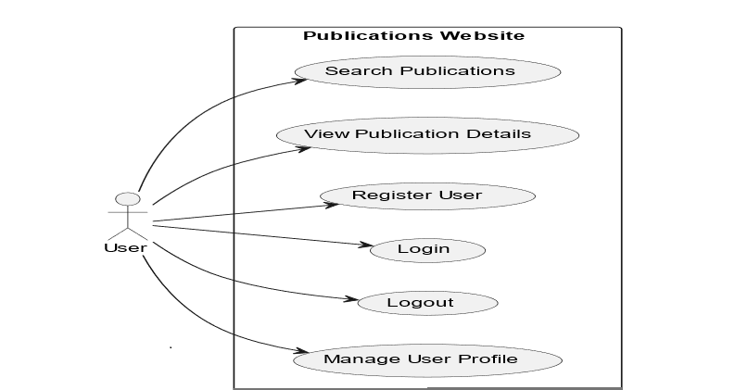

Fig 4.2.1.1 Use case Diagram for users

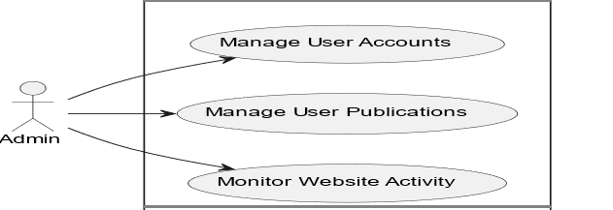

Fig 4.2.1.2 Use case Diagram for Admin

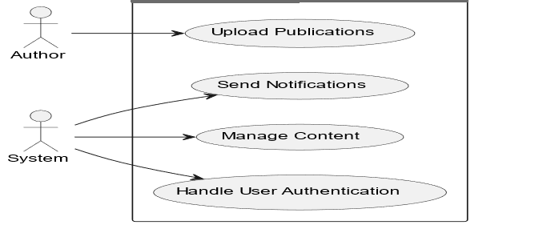

Fig 4.2.1.3 Use case Diagram for Authors

* + 1. **Class Diagram:**
* The class diagram, which is a sort of UML (Unified Modelling Language) diagram that depicts the structure and organisation of a system or software programme, is displayed in Figure 4.2 It is an essential tool for building and modelling object-oriented systems because it gives a visual representation of the classes, objects, connections, and attributes inside a system.
* A system's or software application's structure and organisation are represented by a class diagram.
* The classes or objects that make up a system, as well as their properties, functions, and connections to other classes, are represented using class diagrams.
* These are a few of the important courses.
* **User:**stands in for a website user.
* Properties: UserID, Username, Email;
* Techniques: Register(), Login(), Logout()
* **Publications**: Represents one of the website's publications.
  + PublicationID, Title, Content, Author are among the attribute.
  + Display() and CommentOn() are the methods.

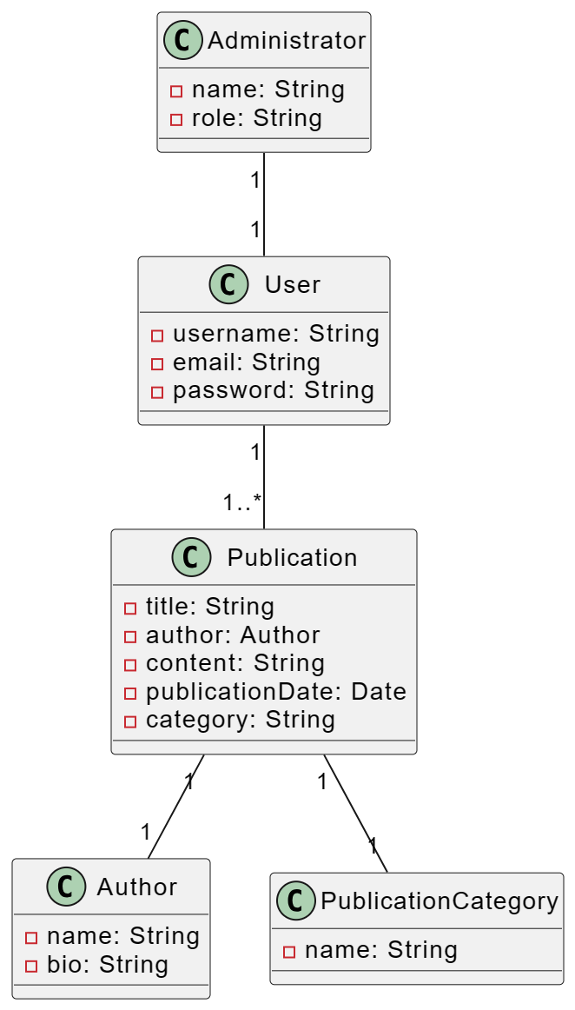

Fig 4.2.2 Class Diagram

**4.2.3 Sequence Diagram:**

One kind of Unified Modelling Language (UML) diagram that shows the relationships and message sequences between various objects or system components is a sequence diagram. It offers a dynamic picture of how several items work together within a system or software programme to complete a specific activity or reach a use case. Figure 4.2.3.1 illustrates how the diagram is depicted:

* A sequence diagram shows how several parts or objects interact with one another over a given amount of time in a system.
* A sequence diagram shows how several parts or objects interact with one another over a given amount of time in a system.**Participants** :
* User
* Website (Controller)
* Server
* A diagram of a website

  Description automatically generatedDatabase

Fig 4.2.3 Sequence Diagram

* + 1. **Activity Diagram:**

The workflow and activities inside a system, process, or business operation are modelled and visualised using an activity diagram, which is a form of Unified Modelling Language (UML) diagram. It is an effective tool for process modelling, analysis, and communication because it offers a high-level perspective of the phases, actions, and decision points involved in a particular process or activity.

* An activity diagram is employed to represent the dynamic elements of a process or system.
* A diagram of a company

  Description automatically generated with medium confidenceIt is especially helpful for visualising the workflow and processes within a system because it depicts the flow of actions, decisions, and activities within it.

Fig 4.2.4.1 Activity Diagram From Login to Logout

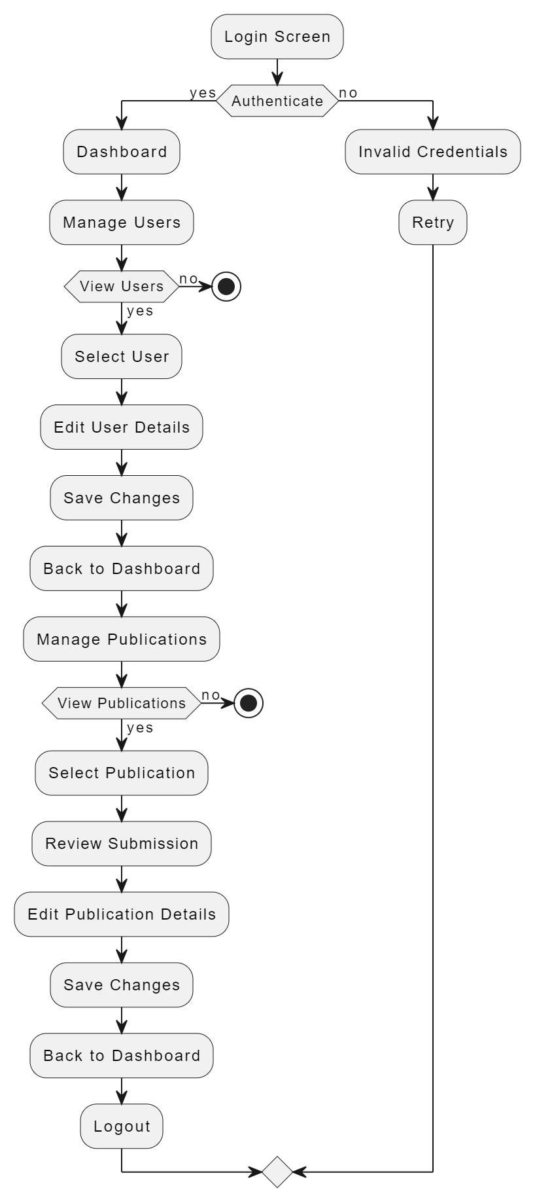

Fig 4.2.4.2Activity Diagram For Admin

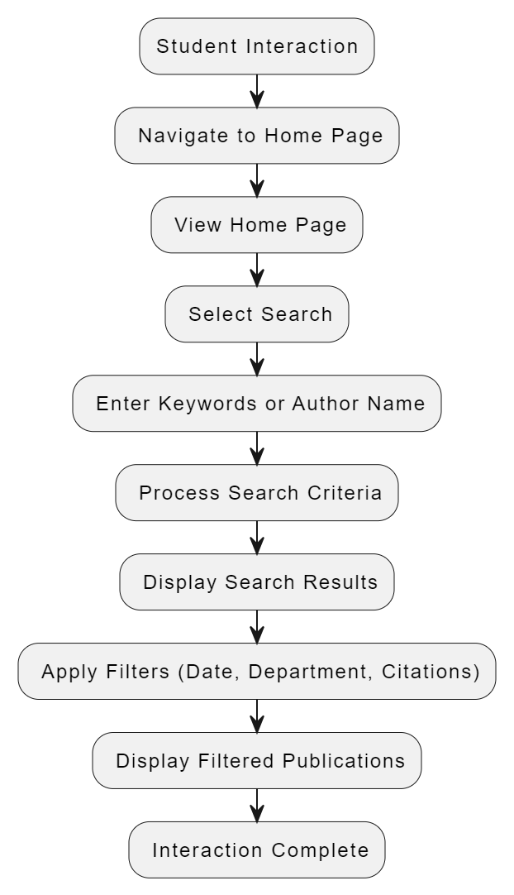

Fig 4.2.4.3 Activity Diagram For Student

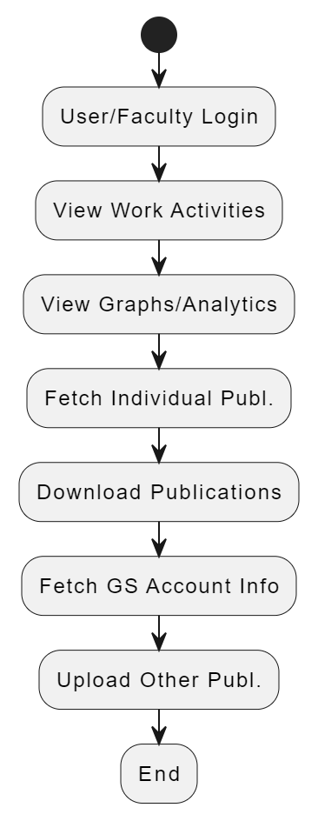

Fig 4.2.4.4 Activity Diagram For User

**CHAPTER 5**

**IMPLEMENTATION**

**5.1 Dataset used:**

A wide range of documents, including book chapters, journals, conferences, and patents, are included in our dataset.

Patents: As seen in fig. 5.1.1, a government licence or authorization that grants a title or right for a predetermined amount of time, particularly the exclusive right to prevent third parties from creating, utilising, or commercialising creations.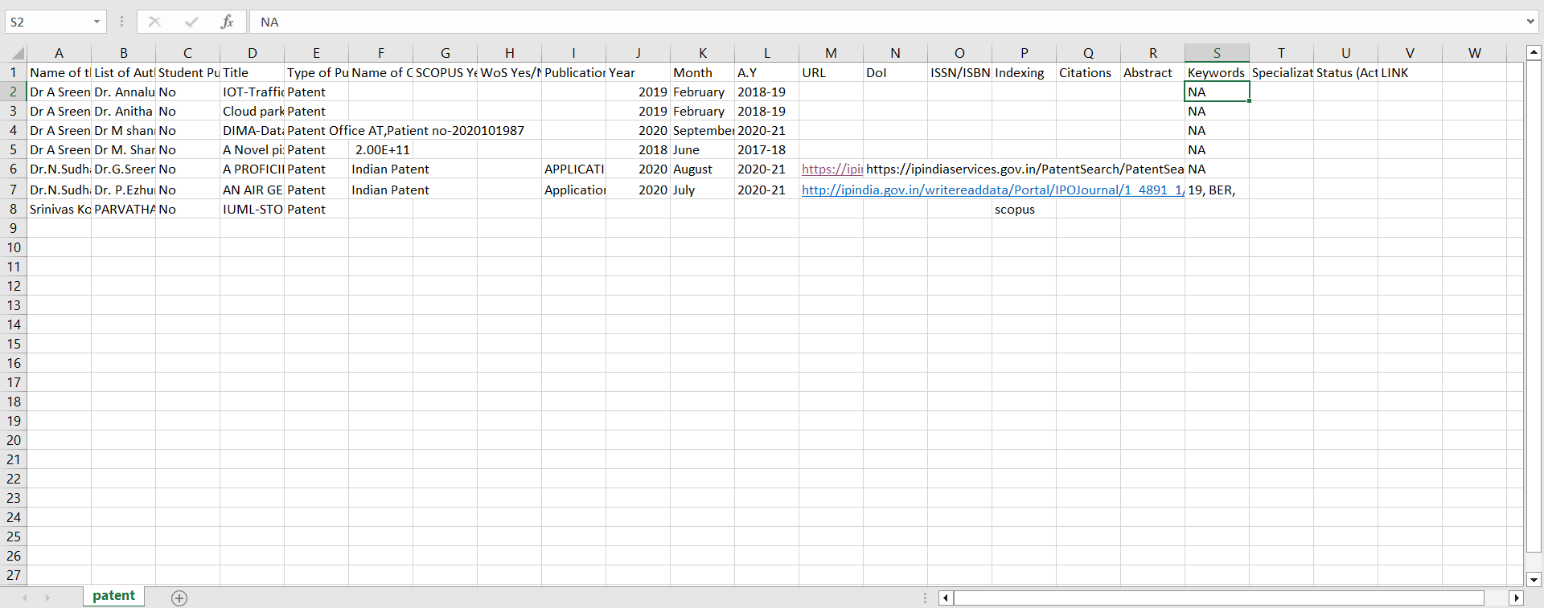

Fig 5.1 Patents

**Journals:**

As shown in fig 5.1.2 newspaper or magazine that deals with a particular subject or professional activity.

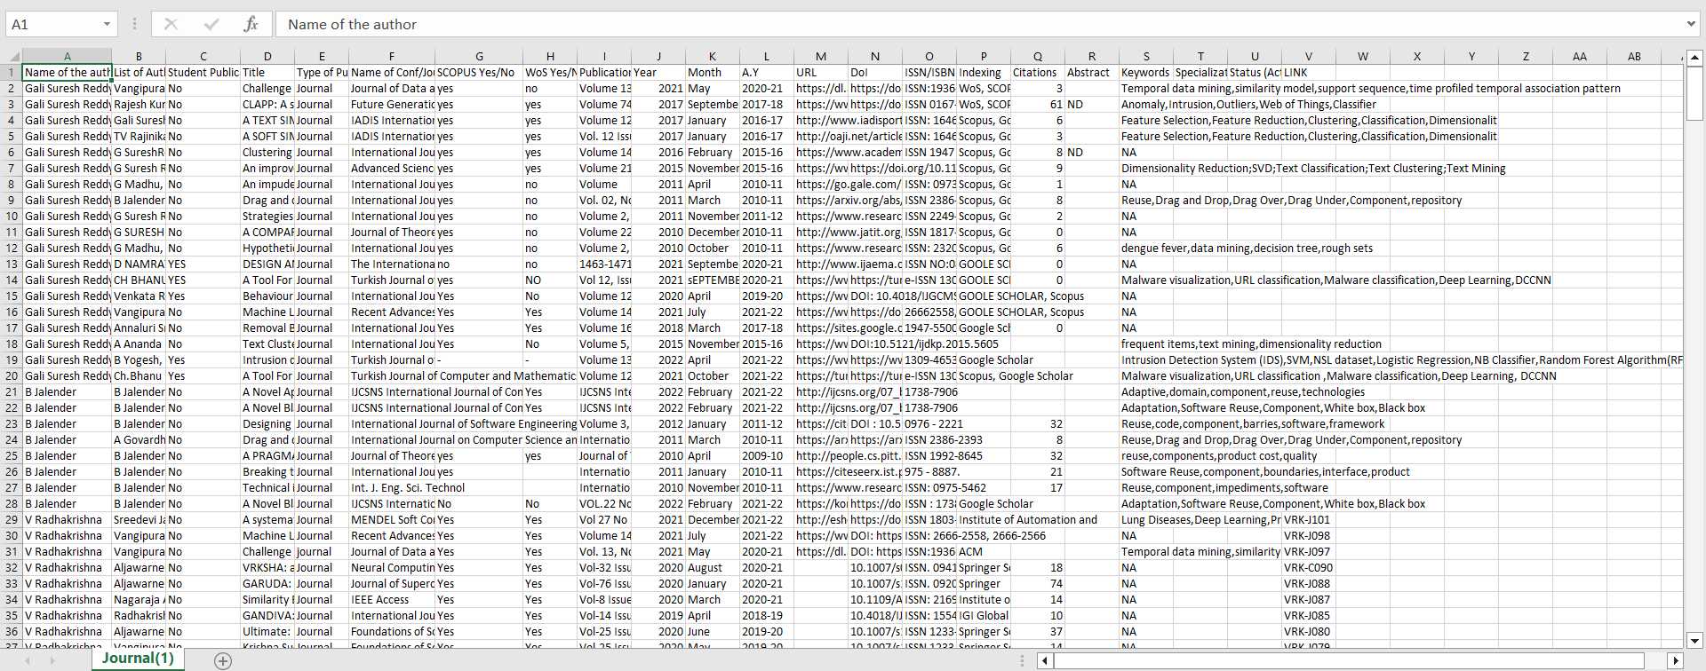

Fig 5.2 Journals

**Conferences:**

As shown in fig 5.1.3 formal meeting of people with a shared interest, typically one that takes place over several days.

Fig 5.3 Conferences

**Book Chapter:**

As Shown in fig 5.1.4 chapter is a chunk of a book that comes to a recognizable end, usually marked by a page break or by an extra space followed by a new numbered or titled chapter.

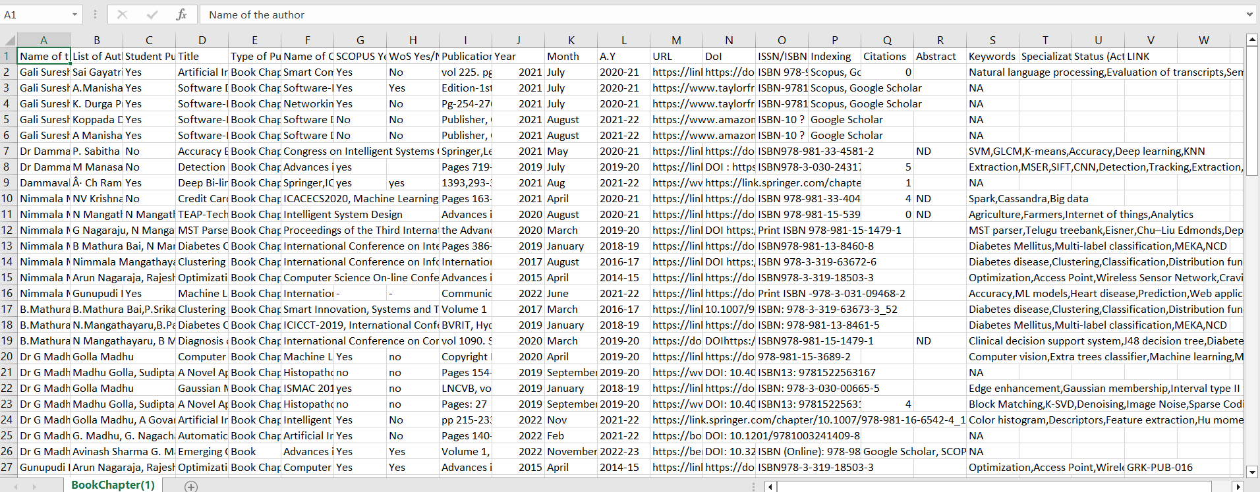

Fig 5.4 Book Chapters

* 1. **Experimental setup:**

Analytics:

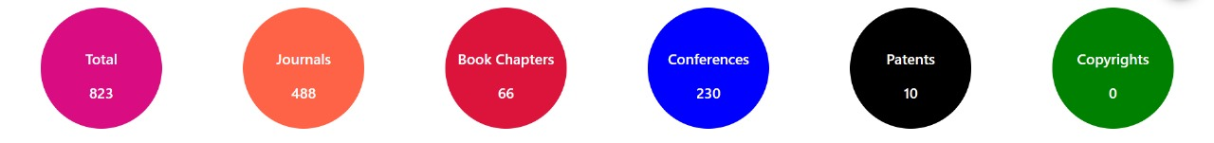

Fig 5.1

Fig 5.1 Shows the analytics about total number of publications and category of the publication and number of publications in each category

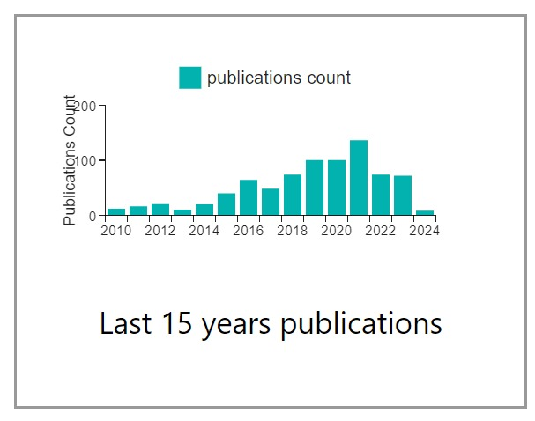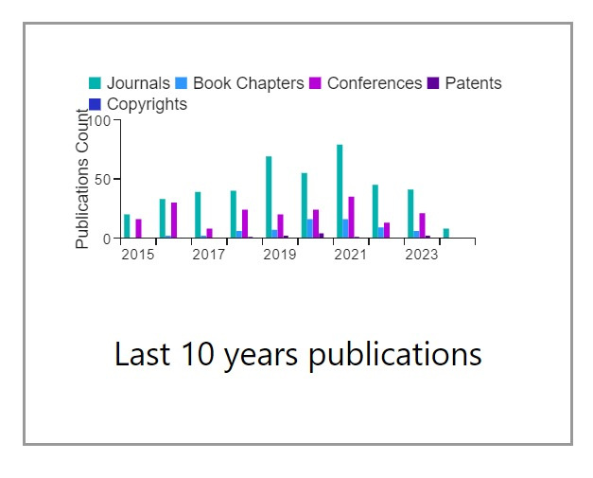

Fig 5.1.1 Fig 5.1.2

Figure 5.1.1 and figure 5.1.2 displays last 15 years and 10 years analytics based on total count and category respectively.

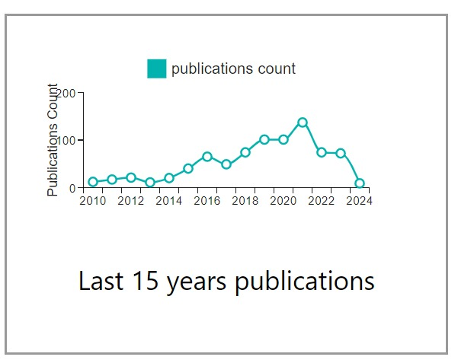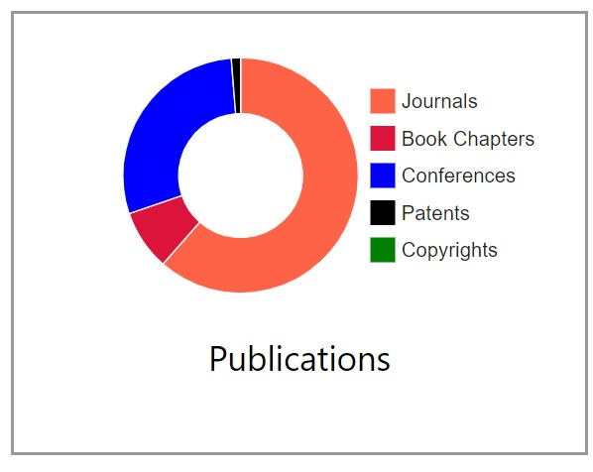

Fig 5.1.3 Fig 5.1.4

Figure 5.1.3 and figure 5.1.4 Illustrates the overall total number of publications and the publication count for the last 15 years using pie charts and line graph.

Home Page:

Fig 5.2 Home Page

Figure 5. 2 Illustrates the overall total number of publications and the publication count for the last 15 years using pie charts and bar graphs.

Fig 5.3 Home Page

Figure 5.3 showcases publications spanning the last 10 to 15 years and includes a navigation menu which provides user to navigate through the department.

Fig 5.4 Home Page

In Figure 5.4, there are 20 publications displayed. If the user wants to view more, they can click on the 'ShowMore' button, it is redirected to login page.

Fig 5.5 Login Page

In Figure 5.5, users can access additional publications by verifying their email and password.

Fig 5.6 Admin Dashboard

Upon successful login with valid credentials, the Admin account will be authenticated, and a summary of the user's details and activities from the past 15 years will be displayed as showed in figure 5.6.

Fig 5.6.1 Upload new option

By Clicking on “Upload new “,admin can upload images to carousel ,can download and upload csv file figure 5.6.1.

Fig 5.6.2 Deleting publications

Admin can delete the publications all at once or selectively as shown in

figure 5.6.2.

Fig 5.6.3 User Profile

Alert box is shown to confirm delete as shown in figure 5.6.3.

Fig 5.6.4 Edit Page

Figure 5.6.4 shows edit page in which all the required fields are displayed and gives access to edit the content.

Fig 5.6.5 Edit Page

Figure 5.6.5 shows edit page in which all the required fields are displayed and gives access to edit the content.

Fig 5.7 User Profile

Upon successful login with valid credentials, the user account will be authenticated, and a summary of the user's details and activities from the past 15 years will be displayed as showed in figure 5.7.

Fig 5.8 User Activity for past 15 years

The chart in Figure 5.8 provides an overview of user details, including their total number of publications, citations, and a 15-year count.

Fig 5.9 User Research Activity corresponding to sites Links.

Figure 5.9 displays various site links for users to access. By clicking on these links, users will be redirected to the respective sites. Additionally, the user's educational details are presented below.

Fig 5.10 Can update, download, and upload Publications.

The diagram labeled 5.10 shows that users have the option to update, download, and upload publications by clicking on the corresponding buttons.

Fig 5.11 Can update, download and upload Publications.

As Shown in figure 5.11, By clicking the FetchGS button, the system updates the total number of publications through web scraping.

Fig 5.12 Can upload Publications.

Users can upload publications by clicking the upload button. They should download the provided template CSV file, fill it out, and then upload the completed CSV file. 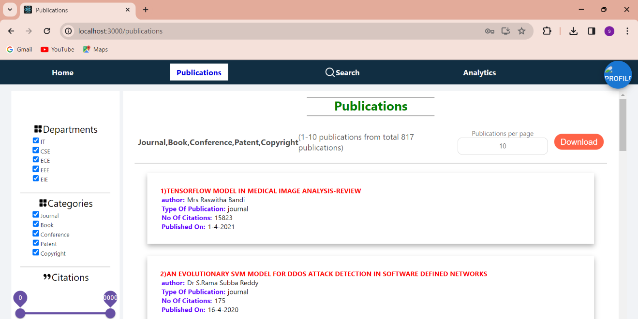+

Fig 5.13 Publications Page.

Figure 5.13 illustrates the total number of publications. Users have the option to download these publications.

Fig 5.14 Publications Page.

Figure 5.14 illustrates the total number of publications. Users have the option to download these publications.

Fig 5.15 Publications Page.

Figure 5.15 illustrates the total number of publications. Users have the option to download these publications

Fig 5.16 Publications Page.

In Figure 5.16, users have the option to apply filters by interacting with checkboxes, drag bars, or date filters. When they click the apply button, the selected filter is applied, and relevant publications are shown. 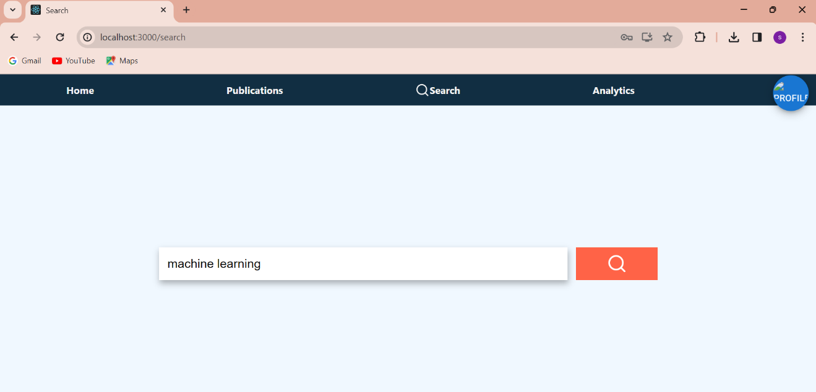

Fig 5.17 Search Page.

The user has the option to search by entering keywords or an abstract, as demonstrated in Figure 5.17.

**Document search using NLP:**

1. **Index Creation:**
   * Define which fields to index (e.g., keywords, abstract, title).
   * Specifies how data should be analyzed during search operations.
2. **Data Ingestion:**
   * Deploy documents onto the database after index creation.
3. **Query Parsing:**
   * User queries sent to the database using $search query operator.
   * Search parses the query to understand user intent, breaking it into tokens and identifying keywords.
4. **NLP Processing:**
   * Techniques include tokenization, lemmatization, part-of-speech tagging, NER, sentiment analysis, and semantic analysis.
5. **Query Execution:**
   * Executes search operation against indexed fields and documents.
   * Utilizes search algorithms like inverted indexes and TF-IDF.
6. **Presentation of Results:**
   * Results returned to the website's backend server and then to frontend for display.

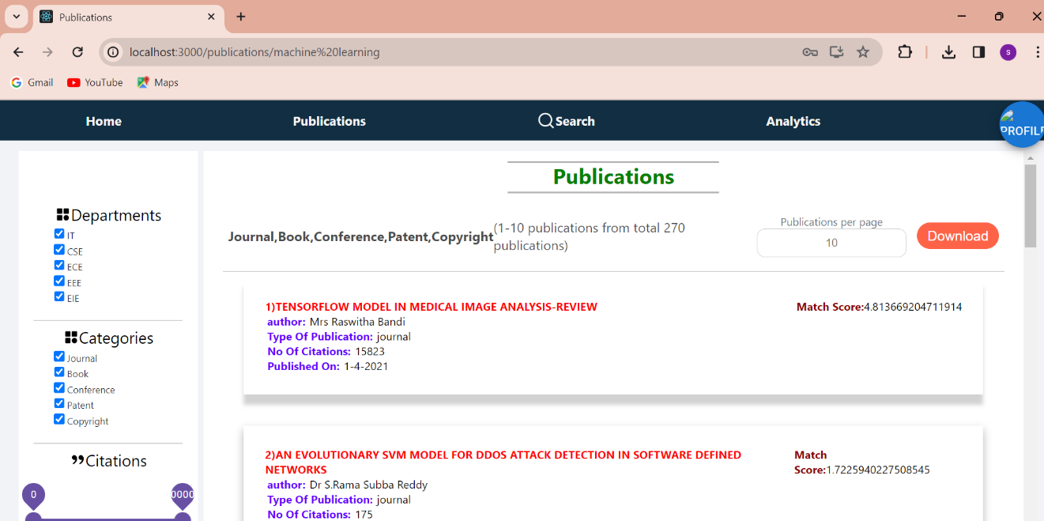

Fig 5.18 search page result

The results are generated and displayed on the screen based on the provided keywords or abstract, as shown in Figure 5.18.

Fig 5.19 Account Logout.

When the user clicks on the logout button, they will be logged out of their account as shown in the figure 5.19.

**CHAPTER 6**

**CONCLUSION**

To sum up, our project marks a significant advancement in the field of academia as we set out on a revolutionary quest to improve the efficacy and efficiency of research material management for academic researchers and college instructors. This project is our answer to the issues presented by the unparalleled era of information dissemination that the modern era has ushered in. We are dedicated to using cutting-edge technology, such as HTML, CSS, JavaScript, ReactJS, MongoDB, and ExpressJS, since we want to provide academics with a cutting-edge tool that makes organising, finding, and retrieving research materials more efficient.

Fundamentally, the goal of this application is to completely transform the way that research resources are accessed by making them simply accessible and discoverable. Users may easily explore a multitude of academic resources with keyword-based and advanced search options, cutting down on search time and improving the effectiveness of their research projects. Additionally, the research experience is made more personalised by the integration of Natural Language Processing (NLP) and Machine Learning (ML) algorithms, which provide customised recommendations based on users' unique study goals.

Beyond the efficiency benefits, our project aims to use data analytics to give academic institutions a complete picture of faculty research activity, enabling them to make well-informed decisions. We place a high priority on having an intuitive and responsive user interface so that users can easily access the programme on many platforms and that strong data security is maintained to protect confidential research materials.

In addition, we understand that continuous user education, assistance, and a sustainability strategy are critical to guaranteeing the application's durability and flexibility. This project is a major achievement at the nexus of technology and academia, not just a technological integration. It has the potential to increase research process productivity and efficacy, making it easier for academics and college instructors to move about the academic environment. As we go, our dedication to enabling academia with a technologically advanced, dynamic solution that maximises the potential of research materials and cultivates a culture of research excellence and knowledge progress does not waver.

**CHAPTER 7**

**FUTURE ENHANCEMENT**

We anticipate a state-of-the-art interface in the future that will seamlessly and effortlessly provide article searches, successfully addressing the shortcomings of the current system. By utilising the latest Machine Learning (ML) techniques along with Natural Language Processing (NLP) capabilities, our system will provide users with extremely precise and context-aware keyword-based and abstract-based searches, hence improving their overall experience. Future improvements will centre on sophisticated data visualisations, utilising machine learning algorithms to produce informative and interactive data representations, in addition to effective searching. These improvements will encourage a culture of research excellence and knowledge progress in the academic community by enabling users to easily locate research resources and to have a deeper grasp of the academic environment through dynamic and personalised data analytics.



Web Browser

**Request**

**Response**

**References**

1. Natural language processing (almost) from scratch ronan r. k. ando and t. zhang. a framework for learning predictive structures from multiple tasks and unlabeled data. jmlr, 6:1817–1953, 11 2005.
2. Ben Wellner, The Mitre Corporation 202 Burlington Road Bedford ,MA USA.
3. Hinton, G.E.; Osindero, S.; The, Y.W. A fast-learning algorithm for deep belief nets. *Neural Comput.* 2006, *18*, 1527–1554.